### A CRM APPLICATION FOR WHOLESALE RICE MILL

**What Is Salesforce?**

Salesforce is your customer success platform, designed to help you sell, service, market, analyze, and connect with your customers.

Salesforce has everything you need to run your business from anywhere. Using standard products and features, you can manage relationships with prospects and customers, collaborate and engage with employees and partners, and store your data securely in the cloud.

### Developer Account Creation:

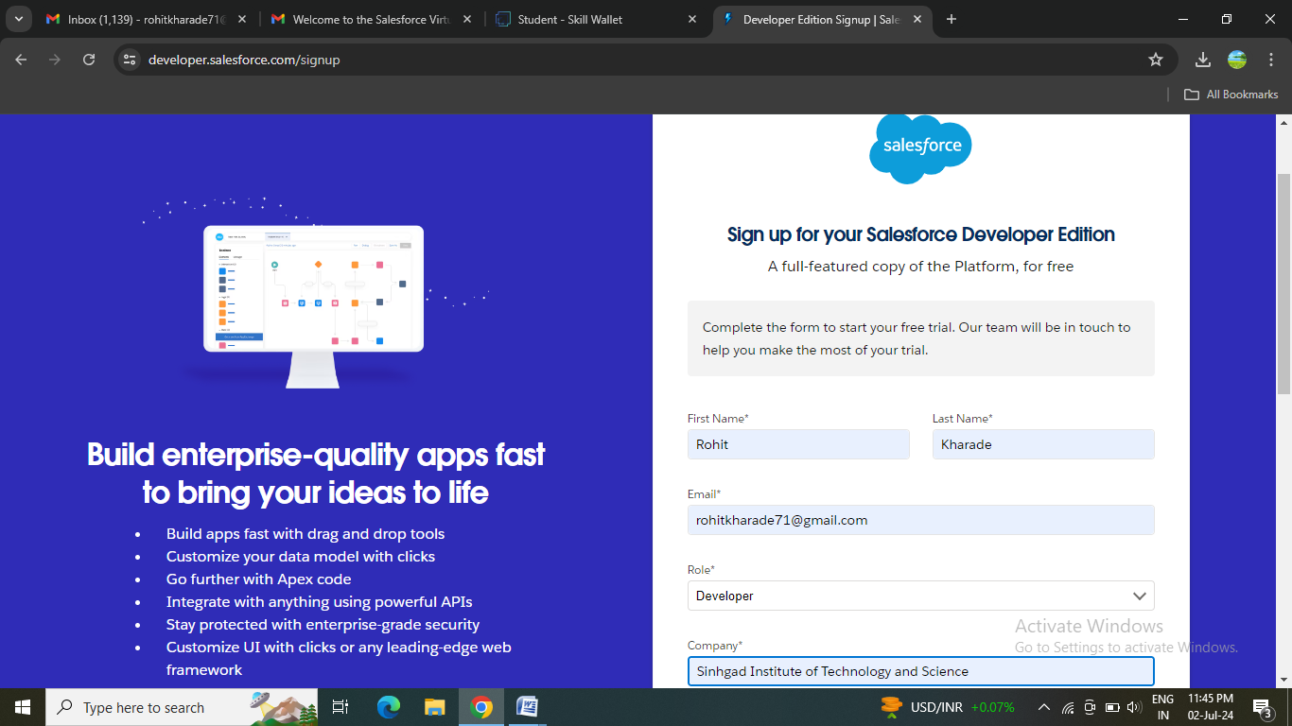

### Account Activation:

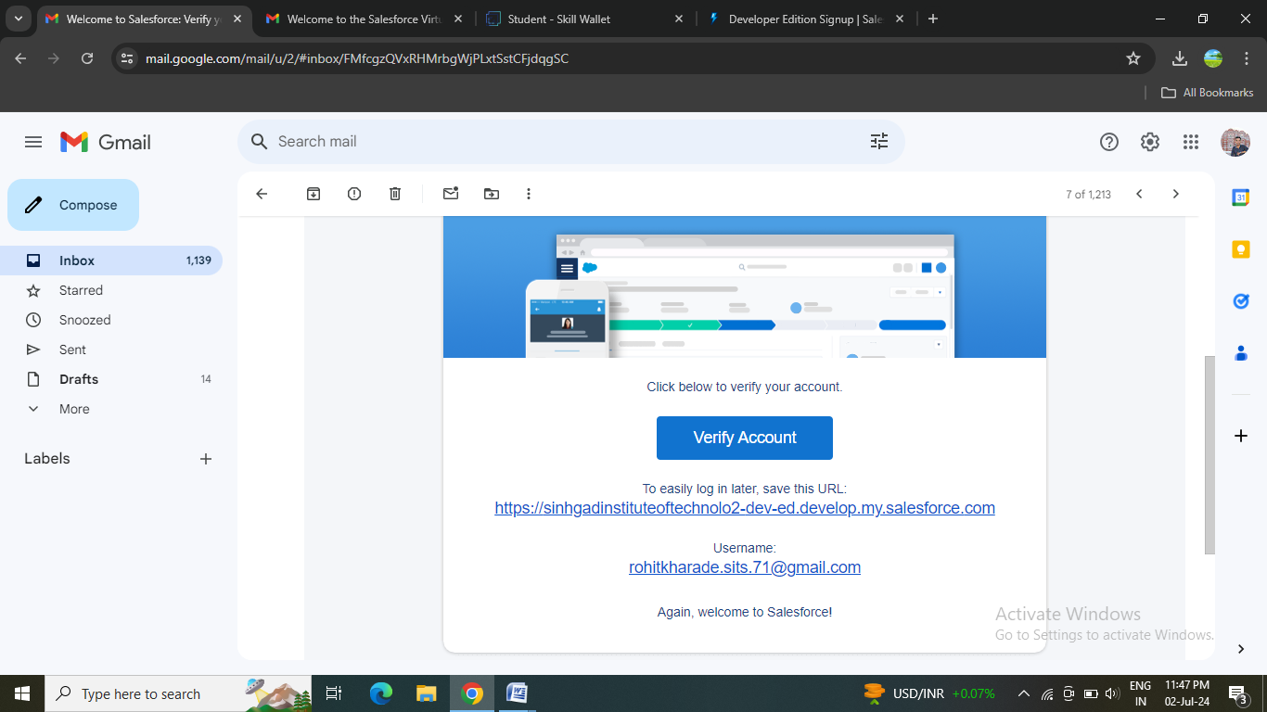

**Object Creation:**

What Is an Object?

Salesforce objects are database tables that permit you to store data that is specific to an organization. What are the types of Salesforce objects

Salesforce objects are of two types:

1. Standard Objects: Standard objects are the kind of objects that are provided by salesforce.com such as users, contracts, reports, dashboards, etc.
2. Custom Objects: Custom objects are those objects that are created by users. They supply information that is unique and essential to their organization. They are the heart of any application and provide a structure for sharing data.

### Supplier Object:

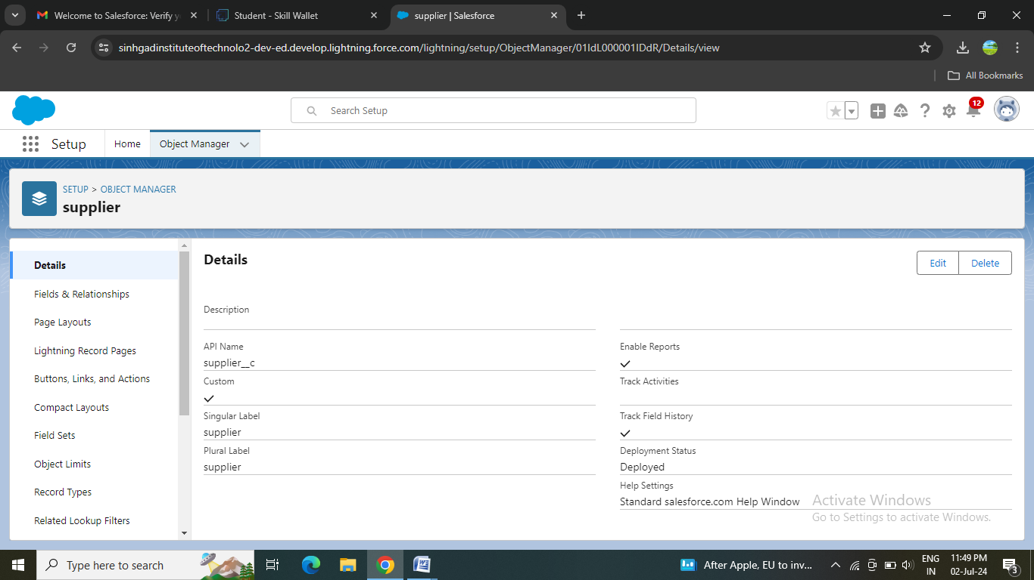

### 

### Rice mill Object:

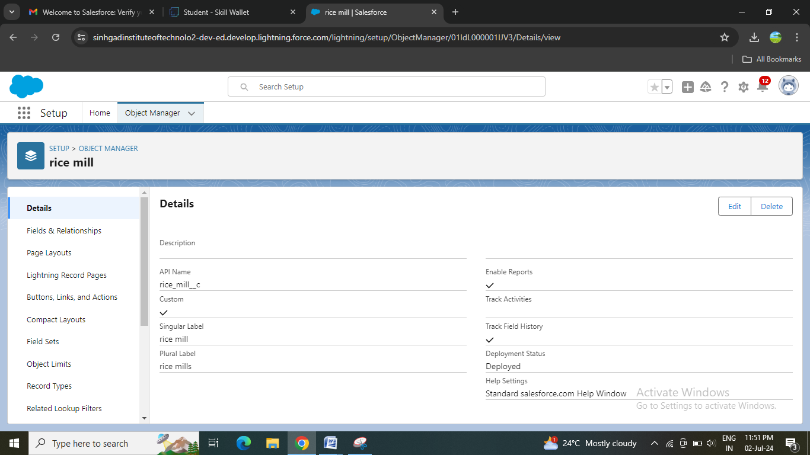

### Consumer Object:

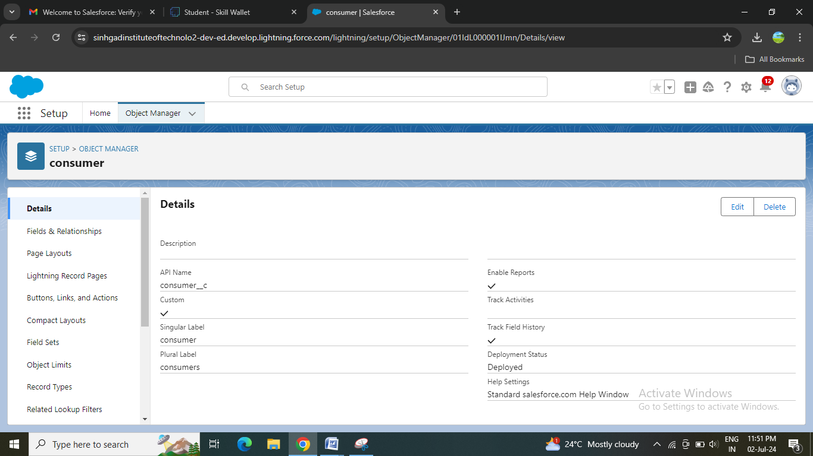

### Rice details Object:

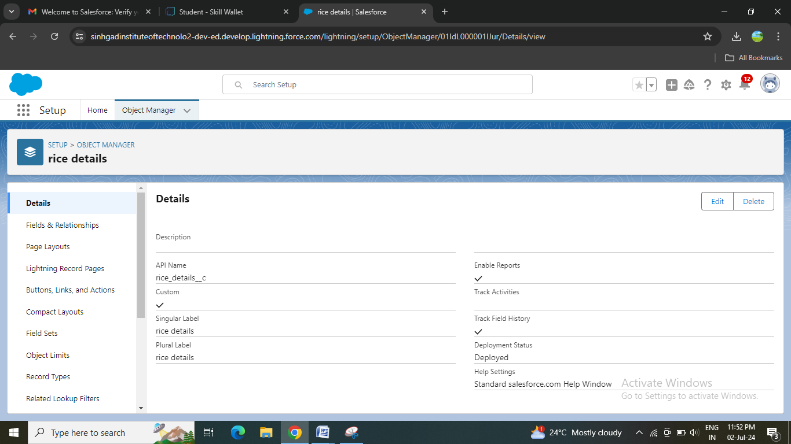

**Creation of Tabs:**

What is Tab?

A tab is like a user interface that is used to build records for objects and to view the records inthe objects.

**Supplier Tab:**

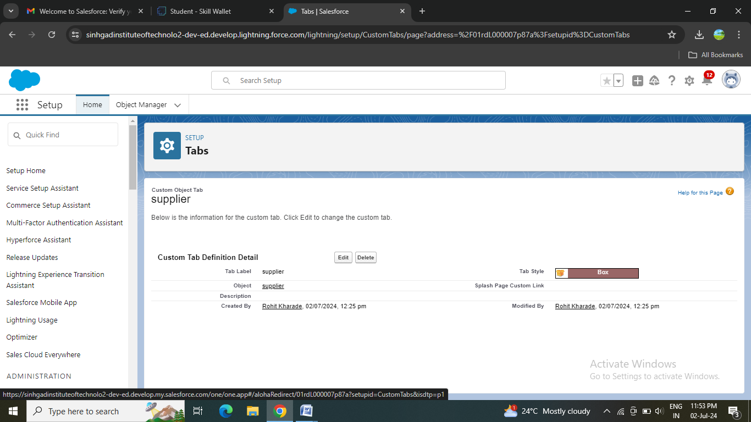

**Consumer Tab:**

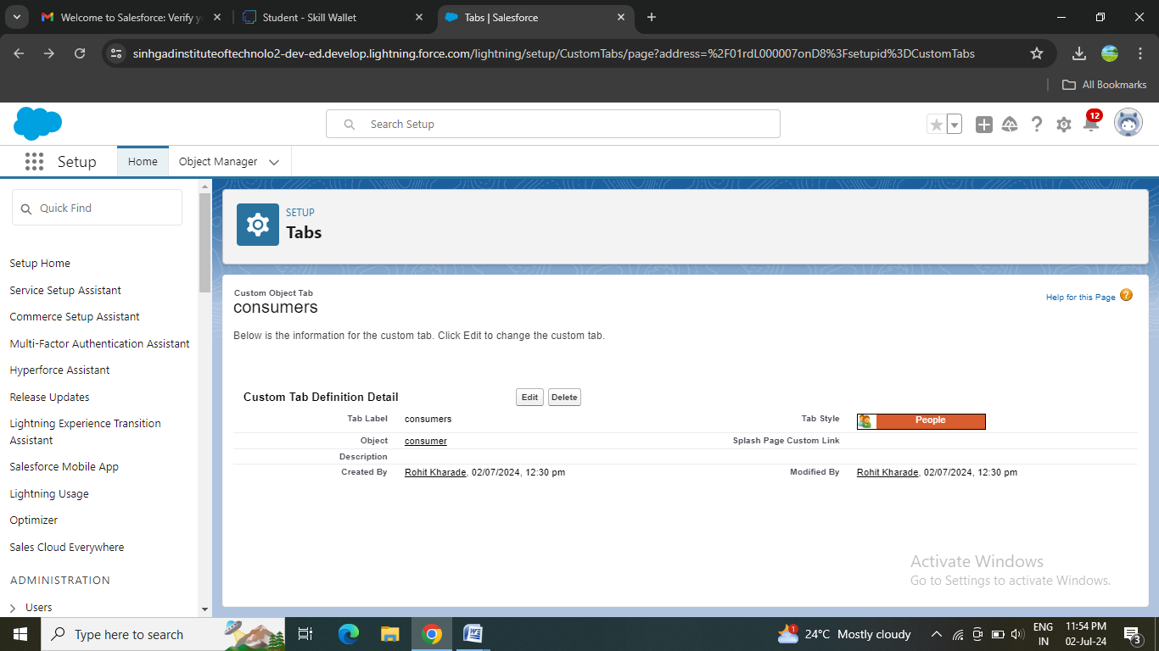

**Rice mills Tab:**

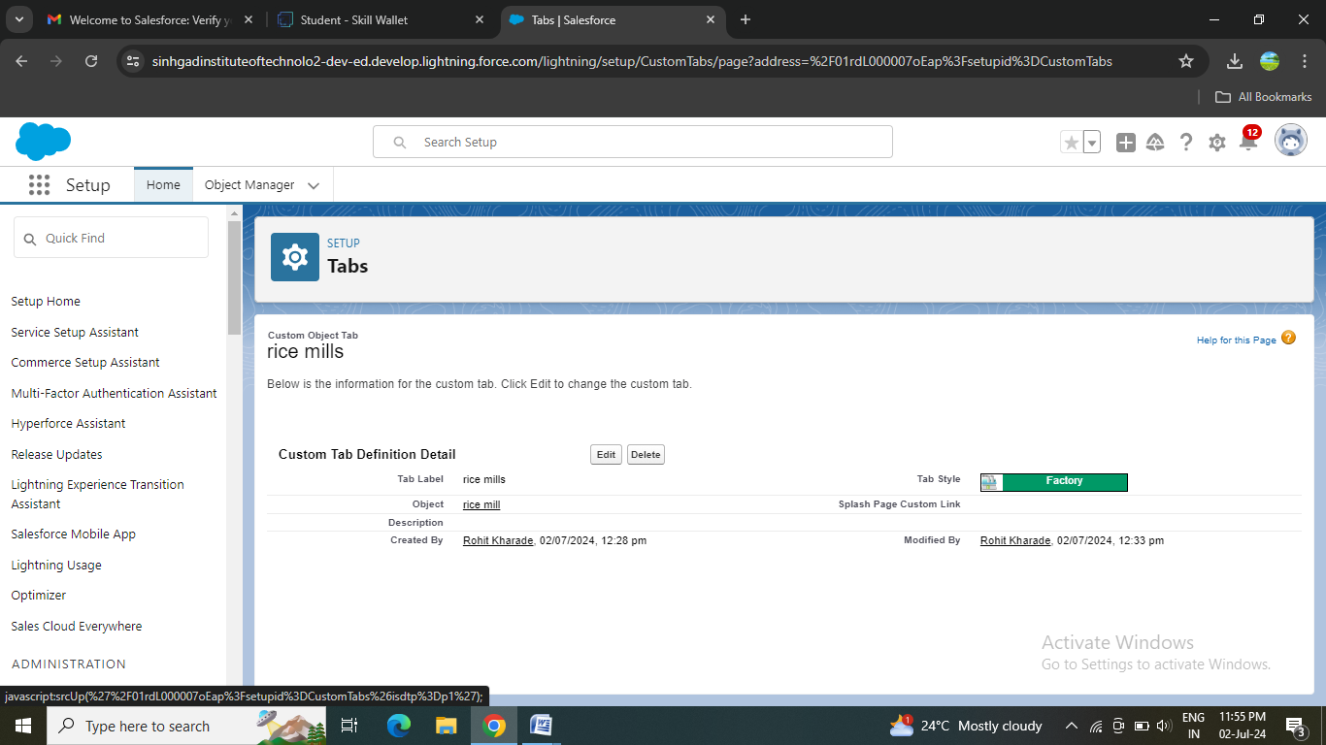

**Rice details Tab:**

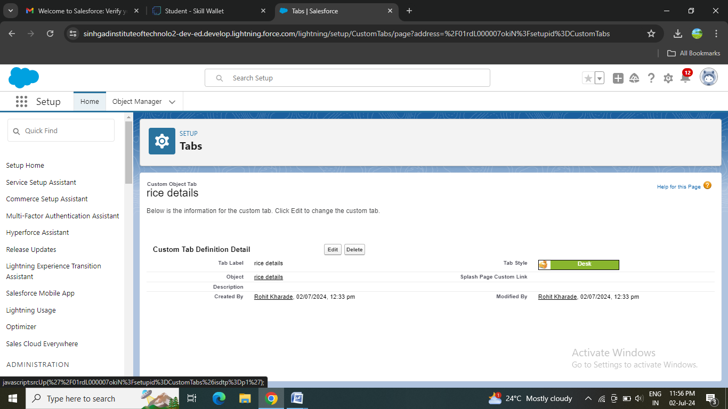

### Lightning App Creation:

What is Lightning App?

An app is a collection of items that work together to serve a particular function. In Lightning Experience, Lightning apps give your users access to sets of objects, tabs, and other items all in one convenient bundle in the navigation bar.

Lightning apps let you brand your apps with a custom color and logo. You can even include a utility bar and Lightning page tabs in your Lightning app. Members of your org can work more efficiently by easily switching between apps.

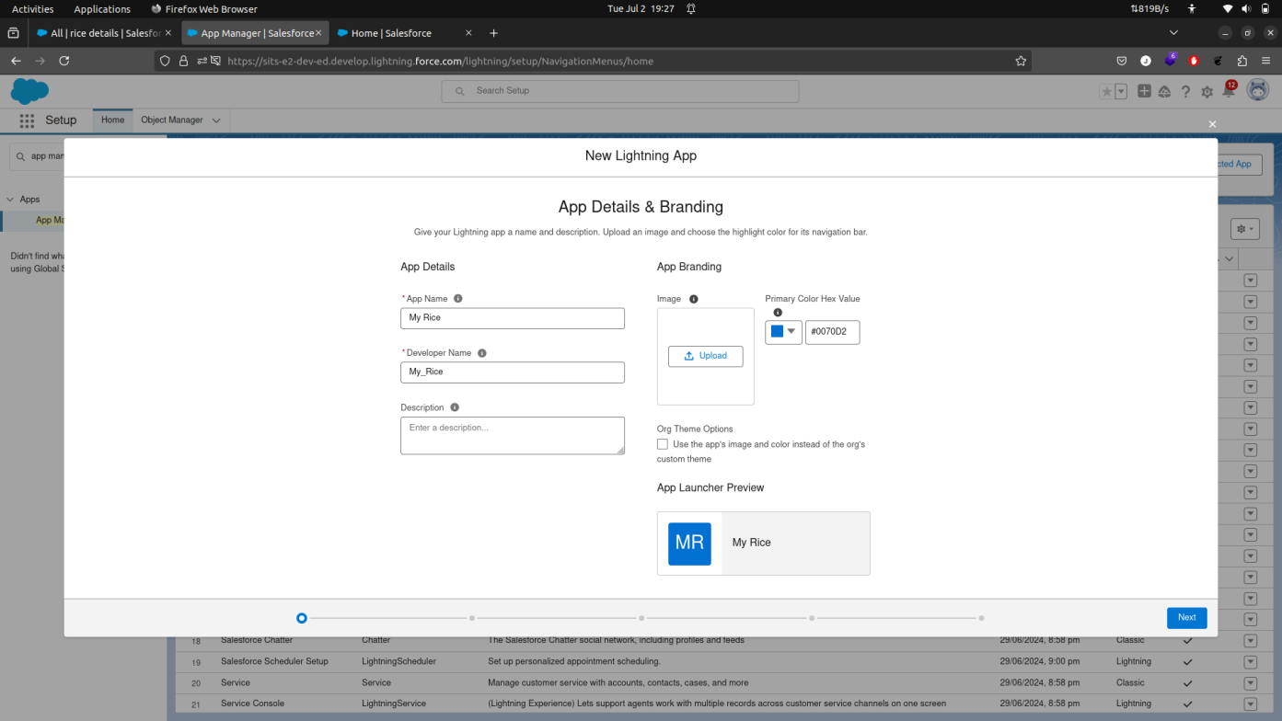

### Field Creation:

### Creating the number field in rice details object

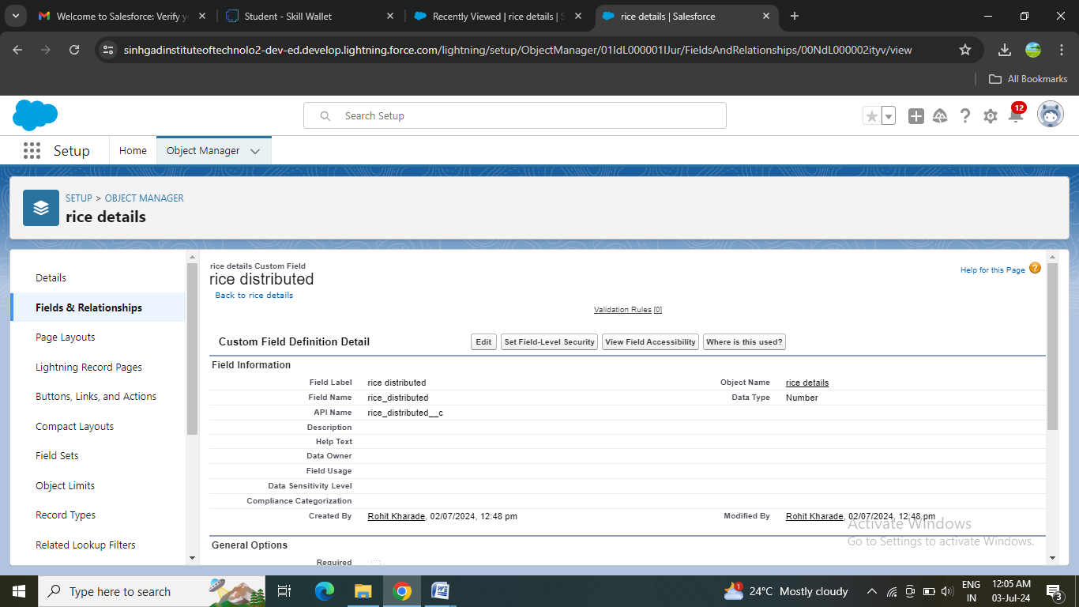

### Creating Junction Object

A Junction  object is a custom object that serves as a bridge between two related objects in a  many-to-many relationship. It allows you to create a relationship between records of two different objects by creating a many-to-many relationship model.

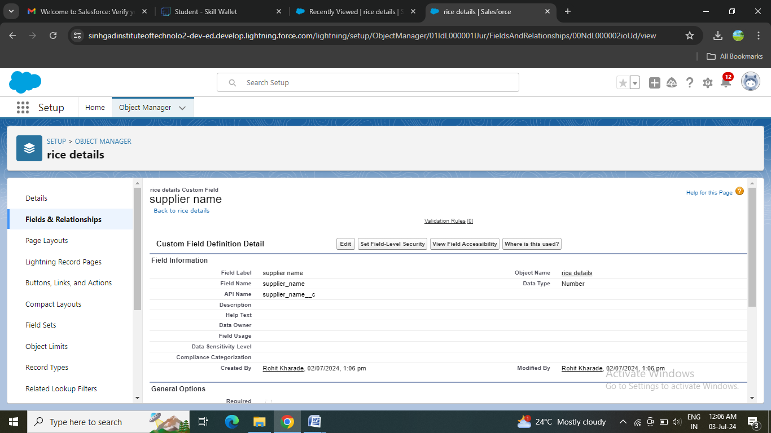

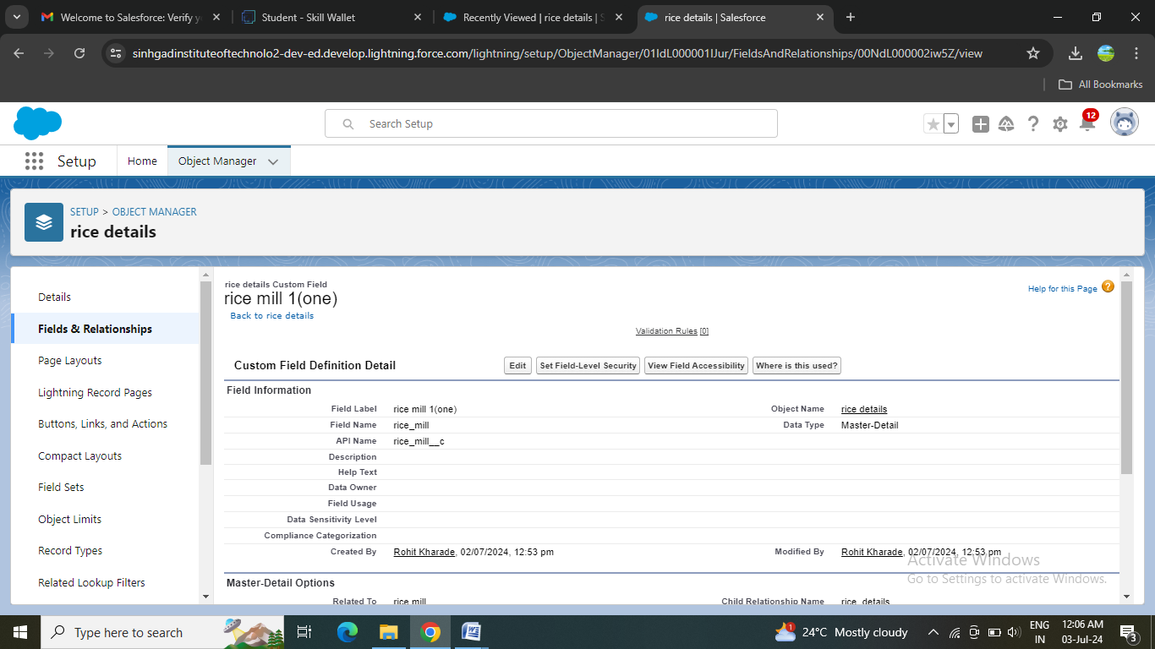

### 

### Creating a Master-Detail Relationship

master-detail relationship is a type of relationship between two objects where the master object controls certain behaviors and settings of the detail object. Here are a few use cases that demonstrate the use of master-detail relationships

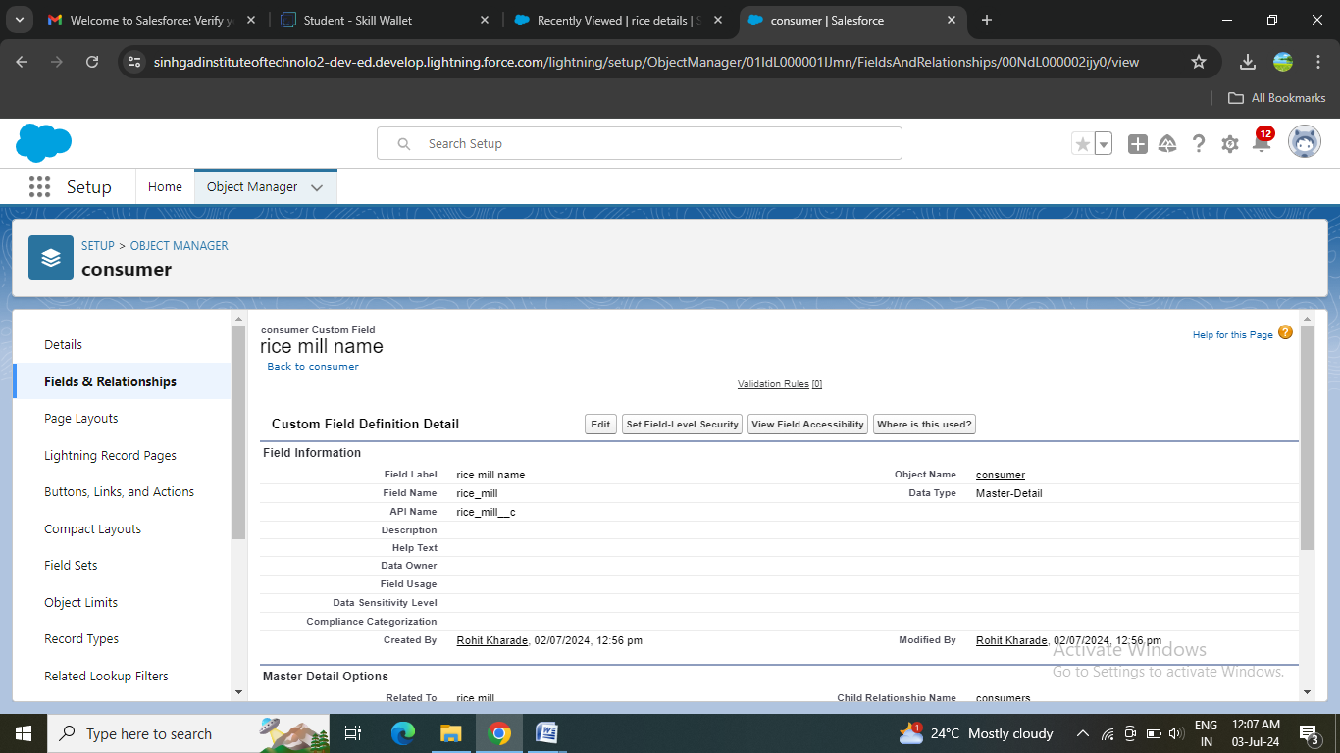

### Creating the Roll-up Summary

A rollup summary field is a field that summarizes data from a child object to a parent object that shares a master-detail relationship. Rollup summary fields can use the COUNT, SUM, MIN, and MAX functions. For example, you could use a rollup summary field to display the total value (amount of rice supplied ) from rice  details on a related supplier.

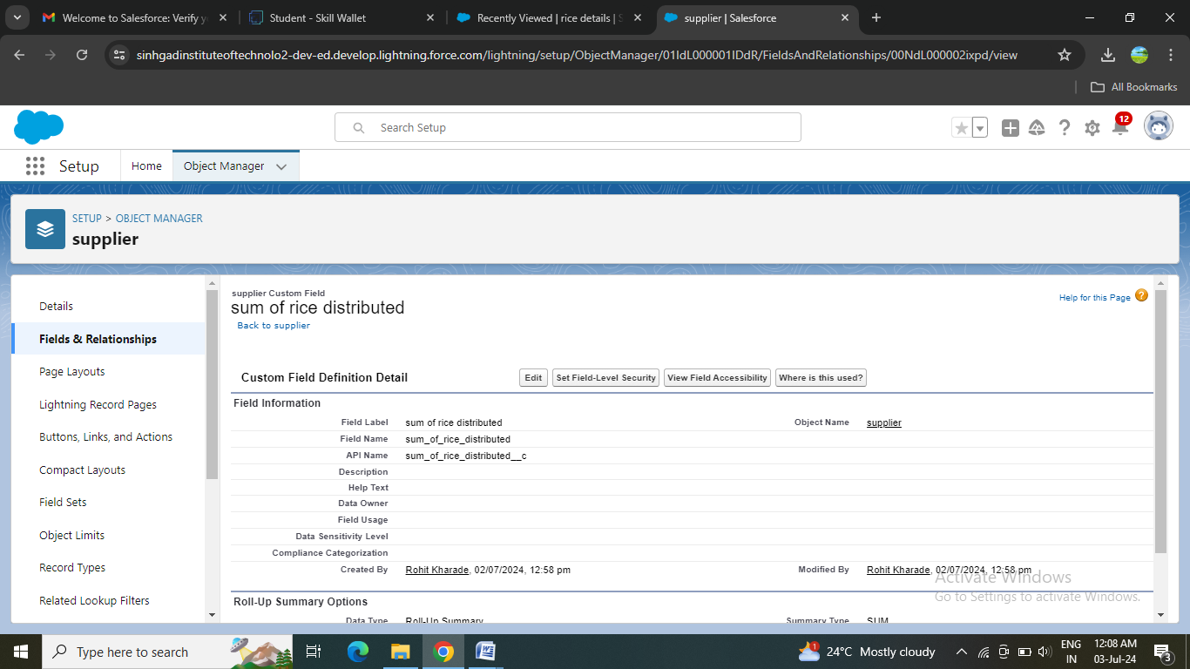

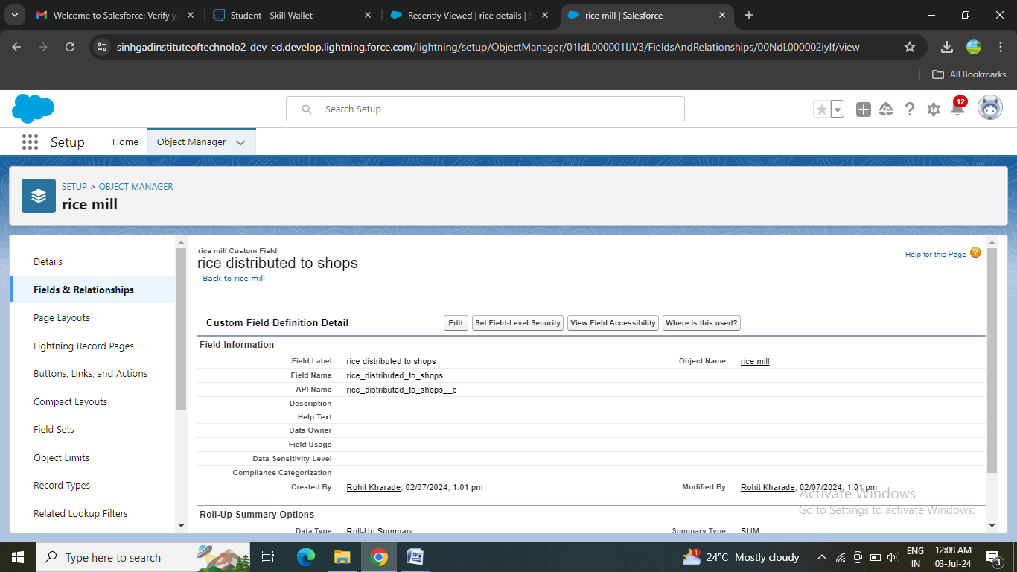

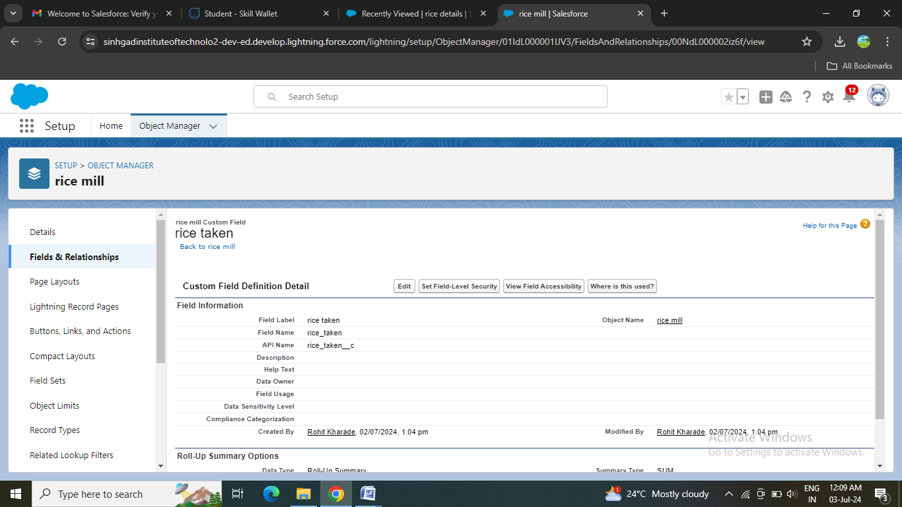

### Creating Fields in Objects

### Screenshot (231).png

### Creating Fields in rice mill Objects

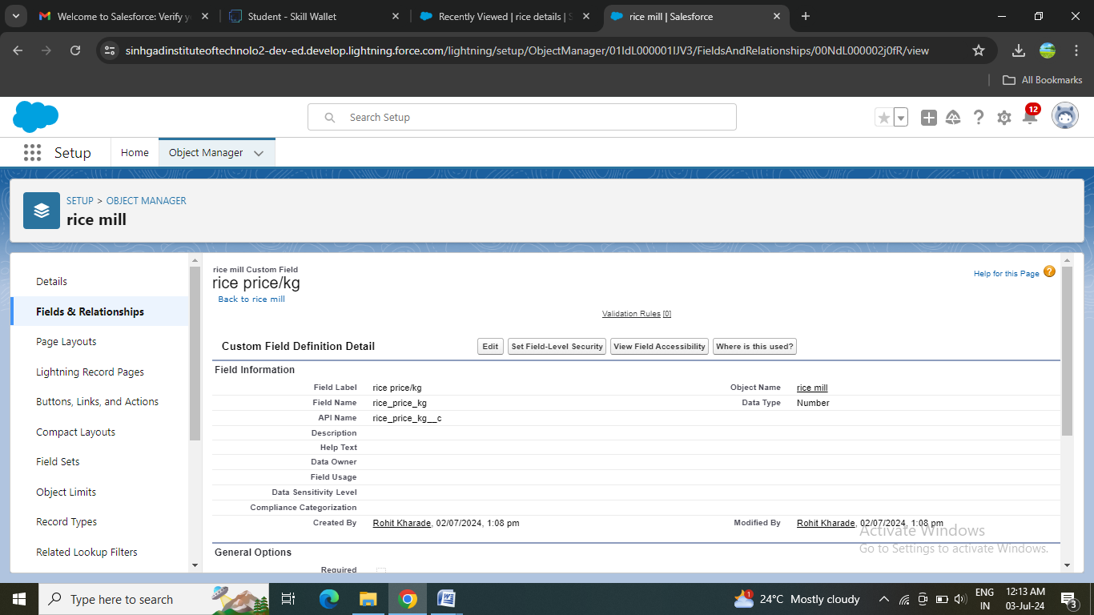

### 

### Creating Fields in consumer Objects

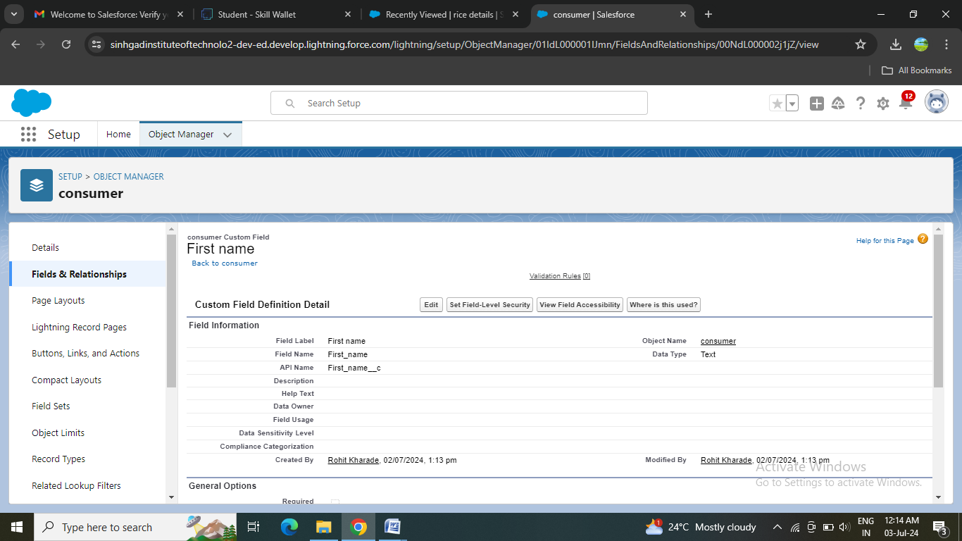

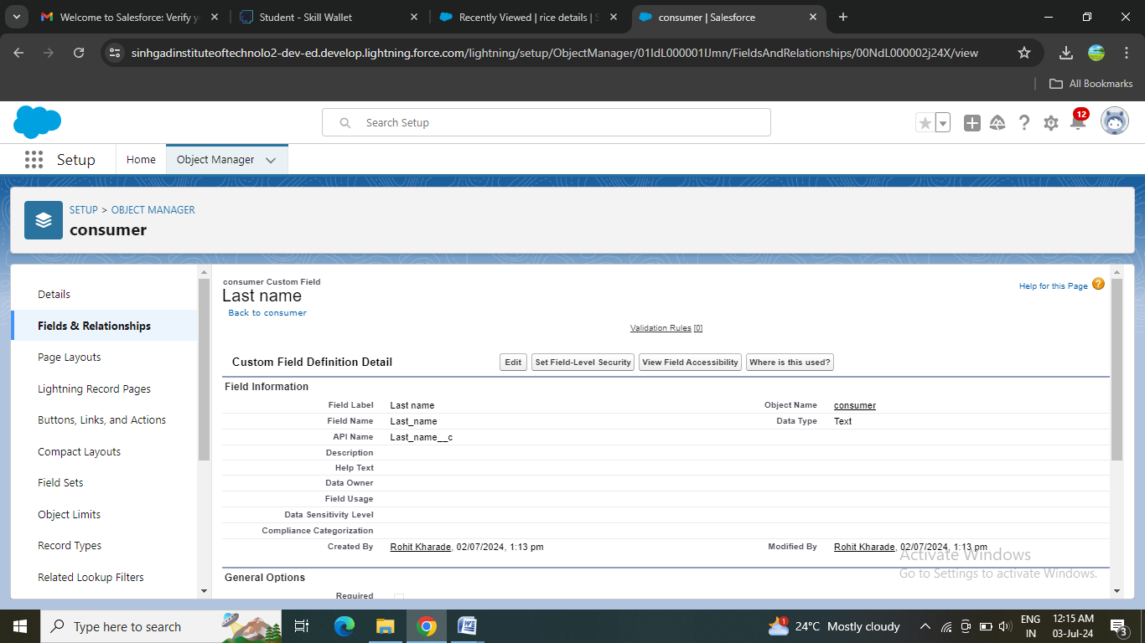

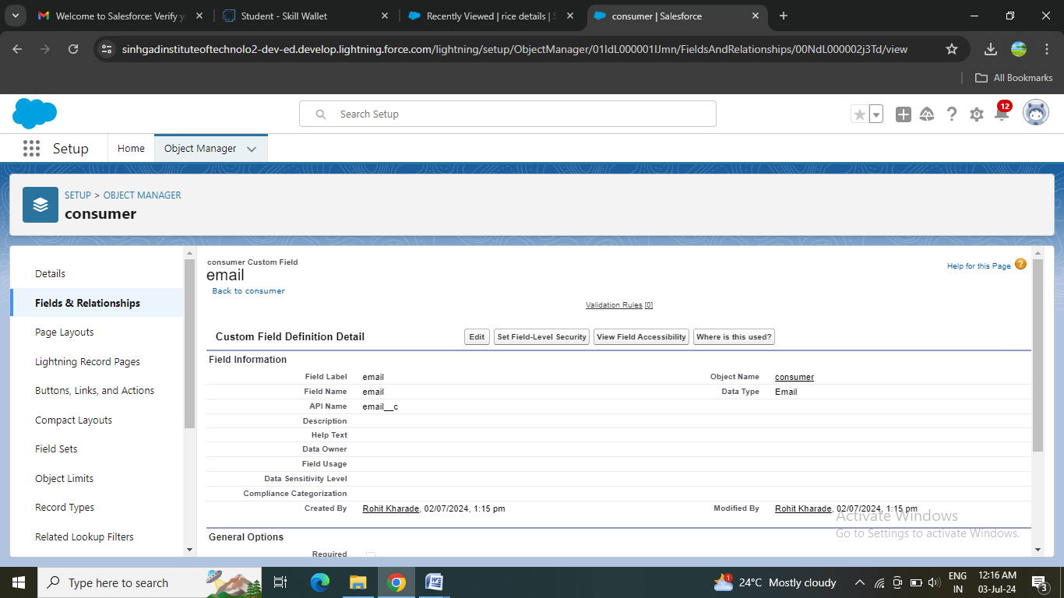

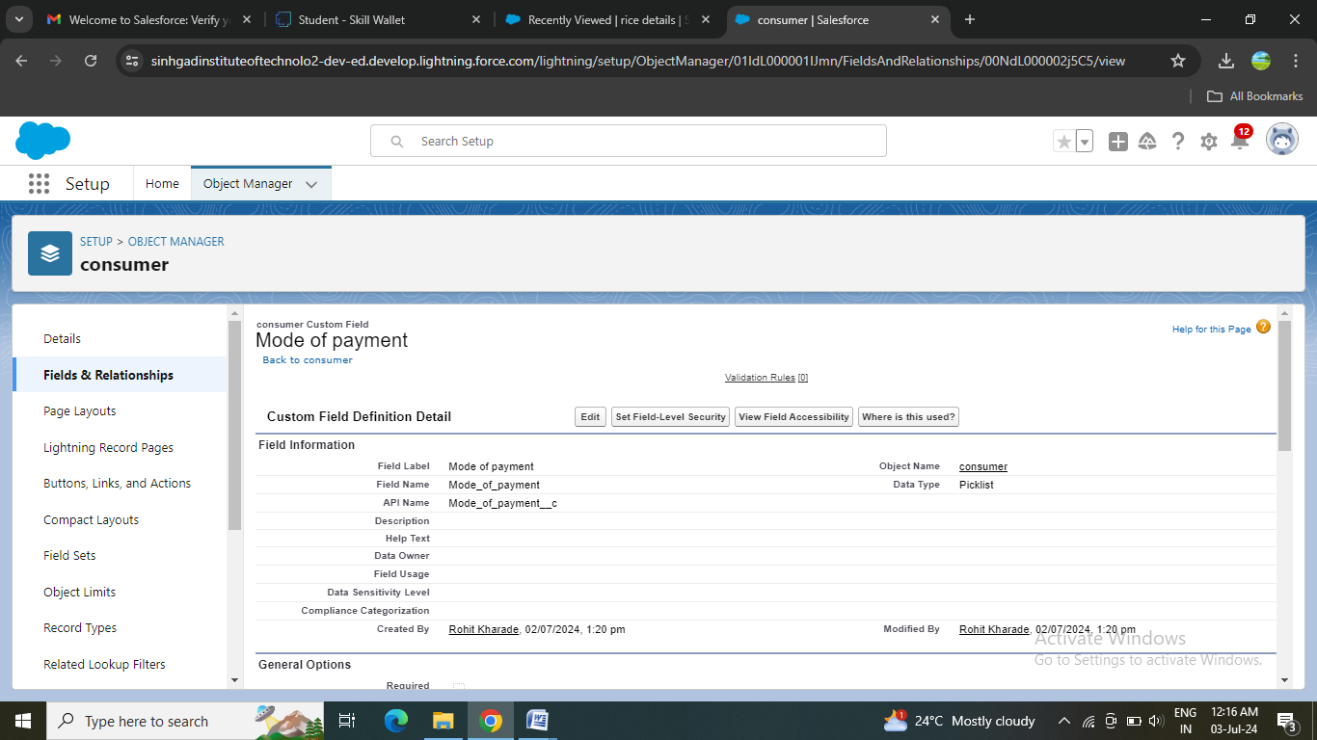

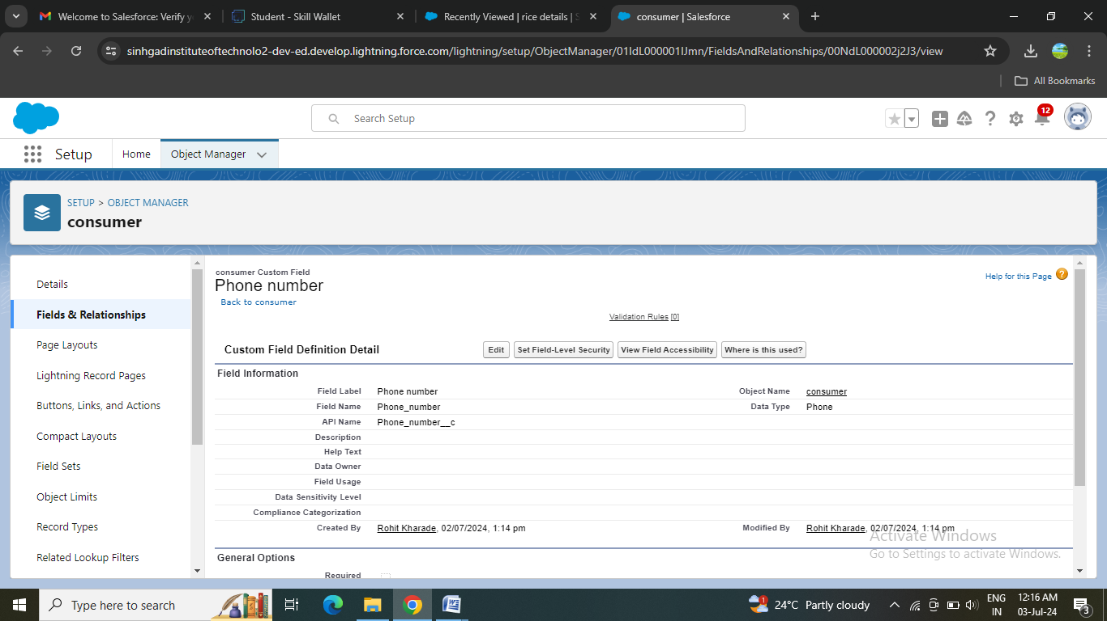

### Creating Cross Object Formula Field in consumer Object

A cross-object formula field is a formula field that references fields from another object in Salesforce. This type of formula allows users to calculate and display data from multiple objects on a single record.

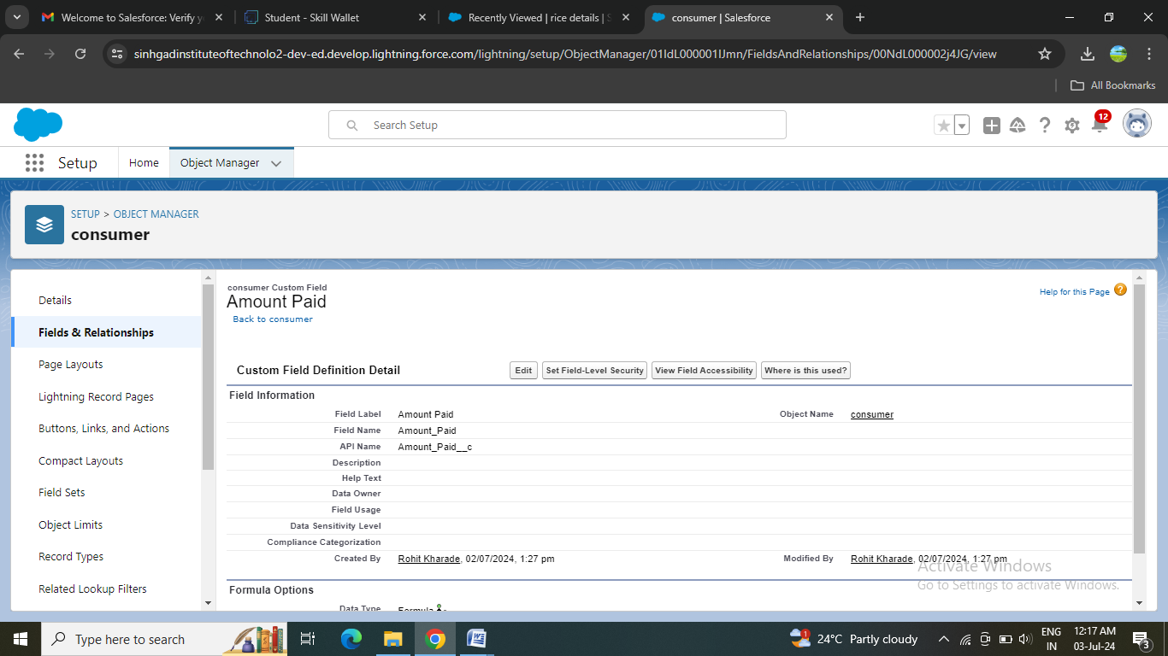

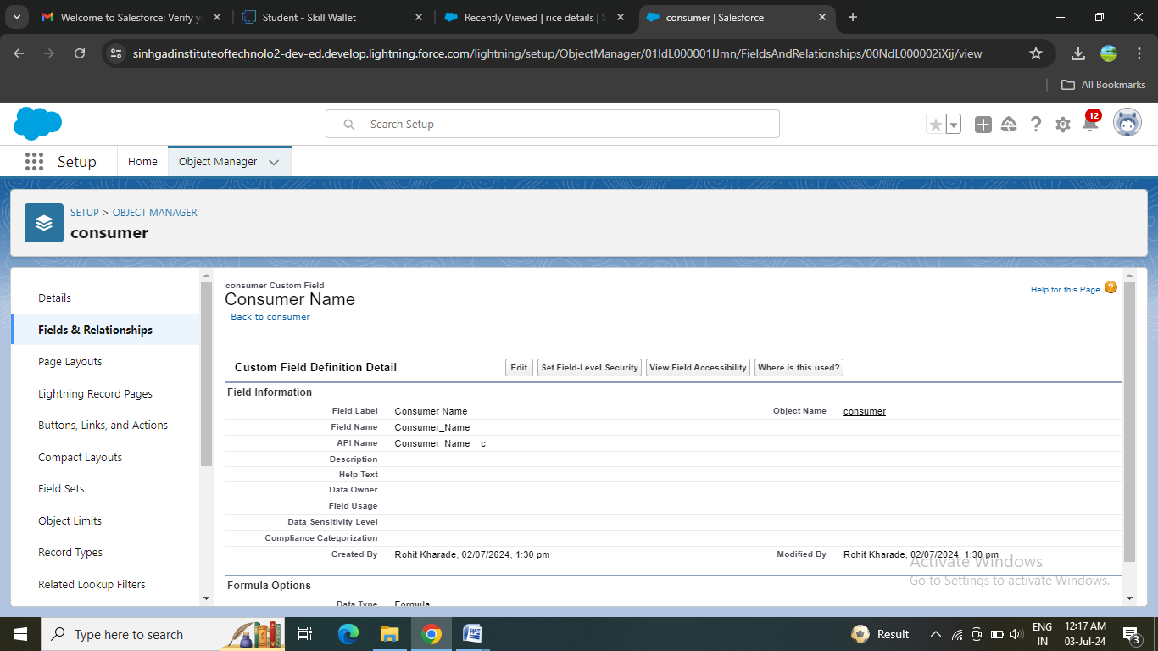

### Creating the validation rule

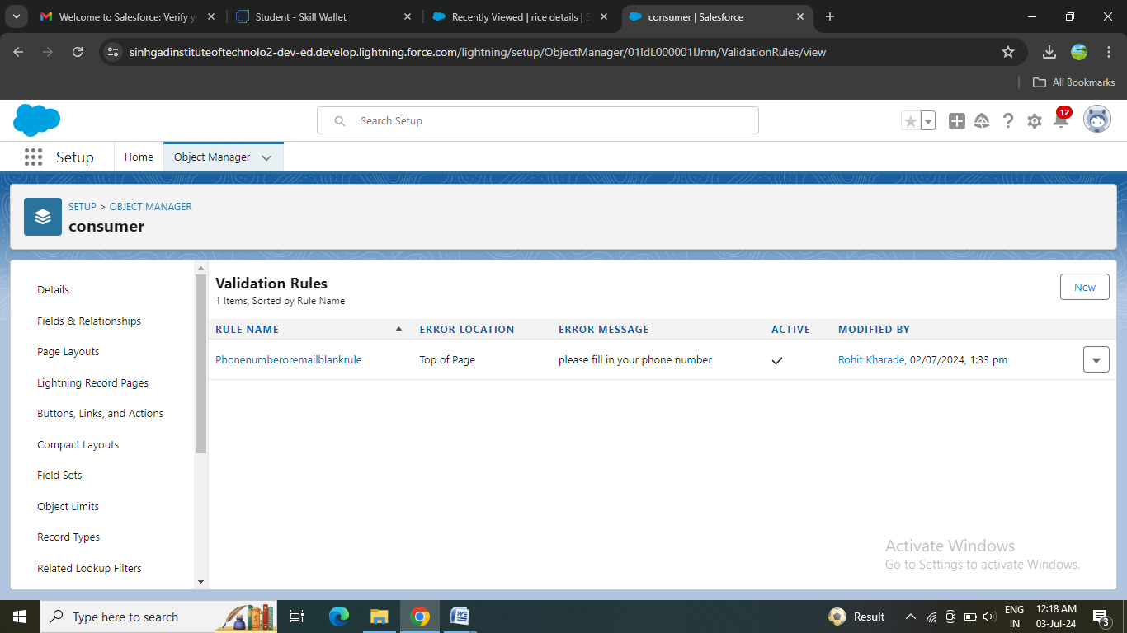

### Page layout Creation:

Page Layout in Salesforce allows us to customize the design and organize detail and edit pages of records in Salesforce. Page layouts can be used to control the appearance of fields, related lists, and custom links on standard and custom objects' detail and edit pages.

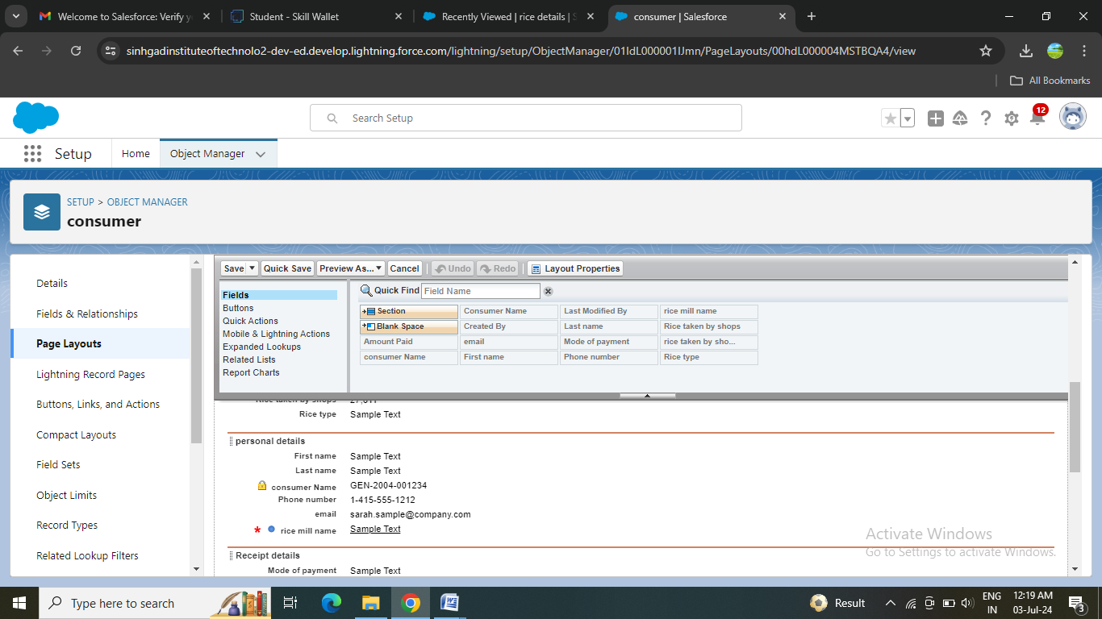

### Profile Creation:

A profile is a group/collection of settings and permissions that define what a user can do in salesforce. Profile controls “Object permissions, Field permissions, User permissions, Tab settings,App settings, Apex class access, Visualforce page access, Page layouts, Record Types,Login hours & Login IP ranges.You can define profiles by the user's job function. For example System Administrator,Developer, Sales Representative.

### Owner Profile

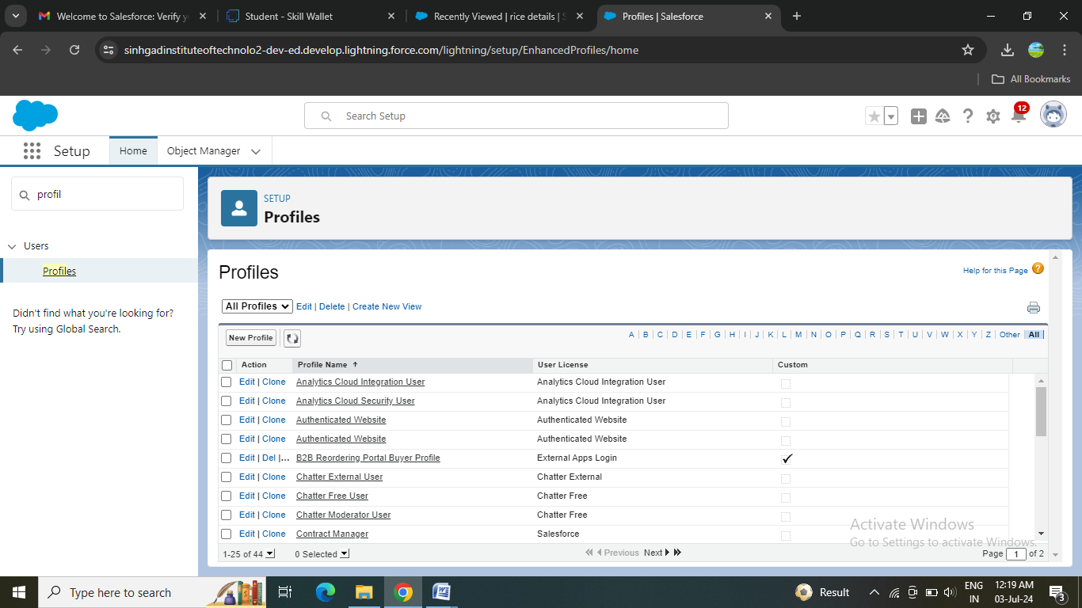

### Employer Profile

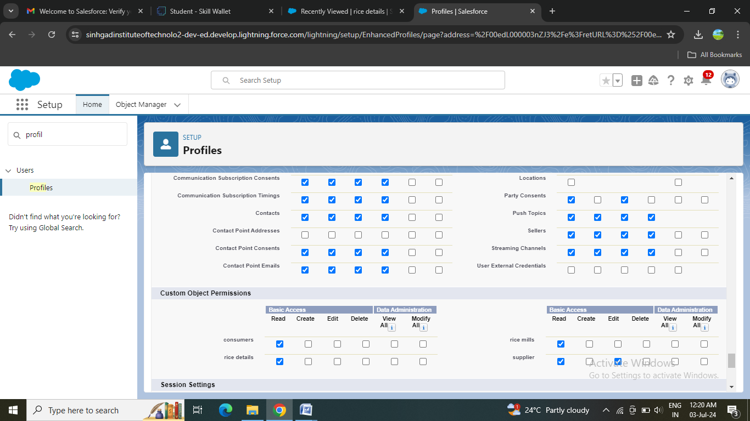

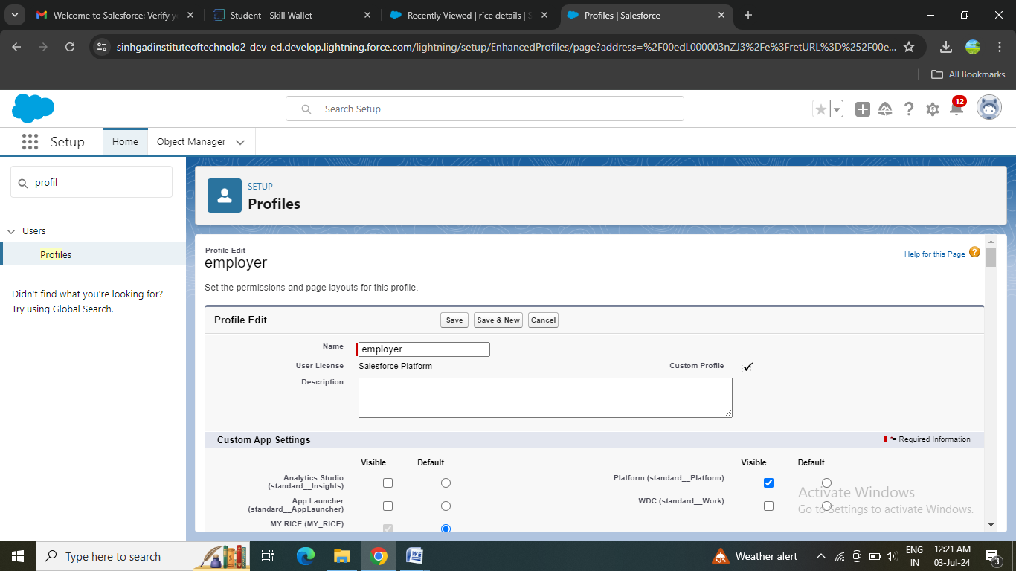

### Worker Profile

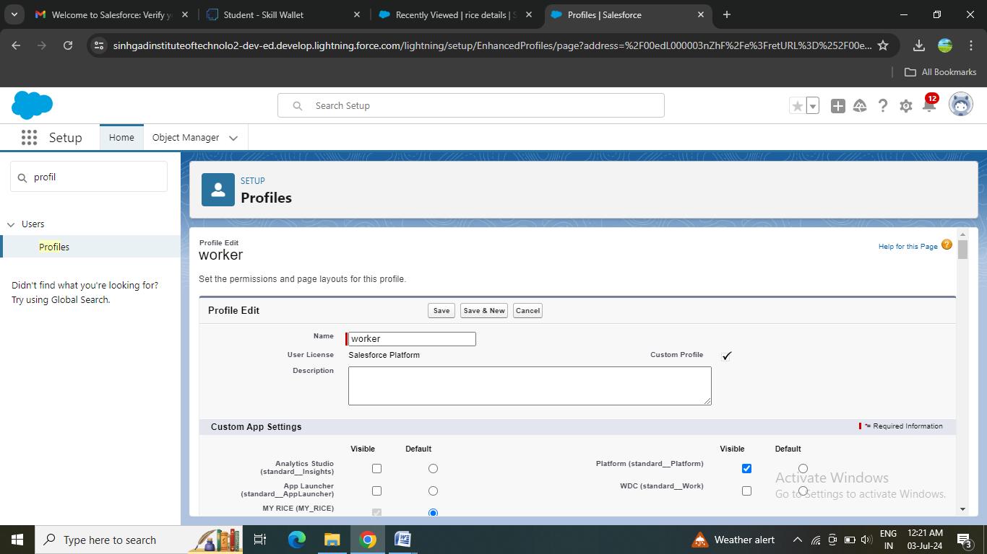

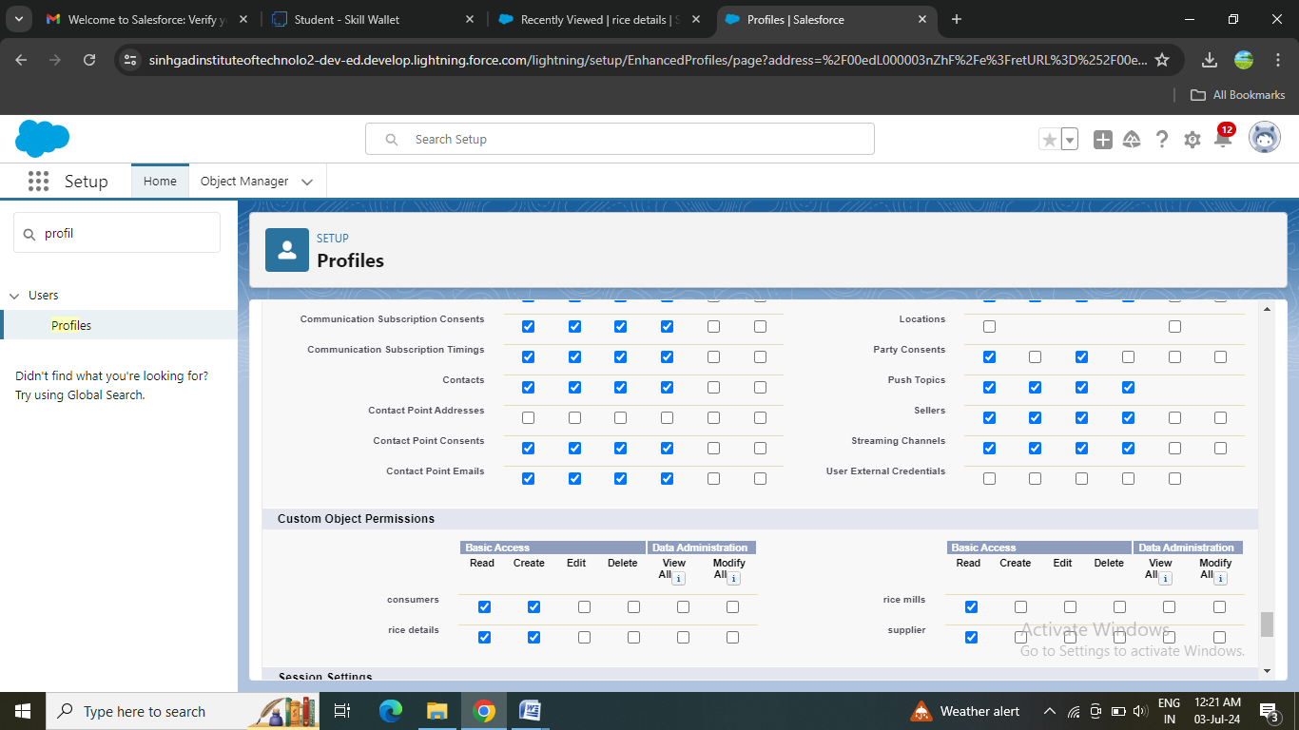

### Role & Role Hierarchy

### A role in Salesforce defines a user's visibility access at the record level. Roles may be used to specify the types of access that people in your Salesforce organization can have to data. Simply put, it describes what a user could see within the Salesforce organization.

### 

### Creating owner Role

### Creating employer roles

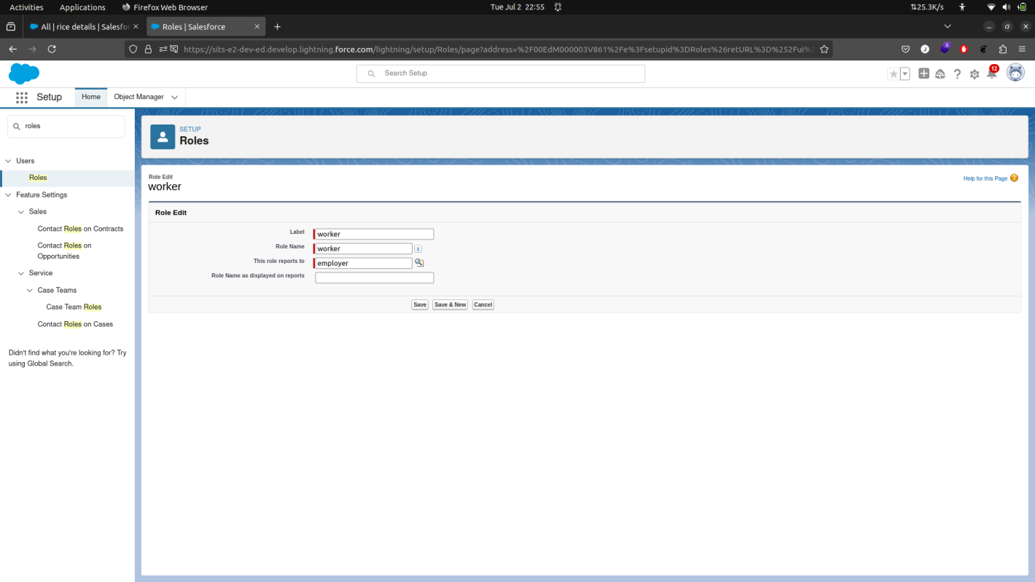

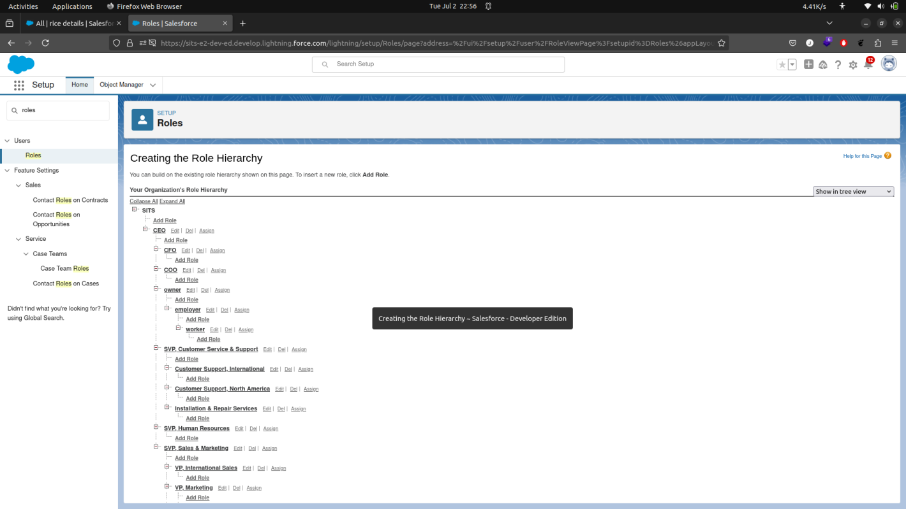

### Users Creation:

### A user is anyone who logs in to Salesforce. Users are employees at your company, suchas sales reps, managers, and IT specialists, who need access to the company's records.Every user in Salesforce has a user account. The user account identifies the user, and theuser account settings determine what features and records the user can access.

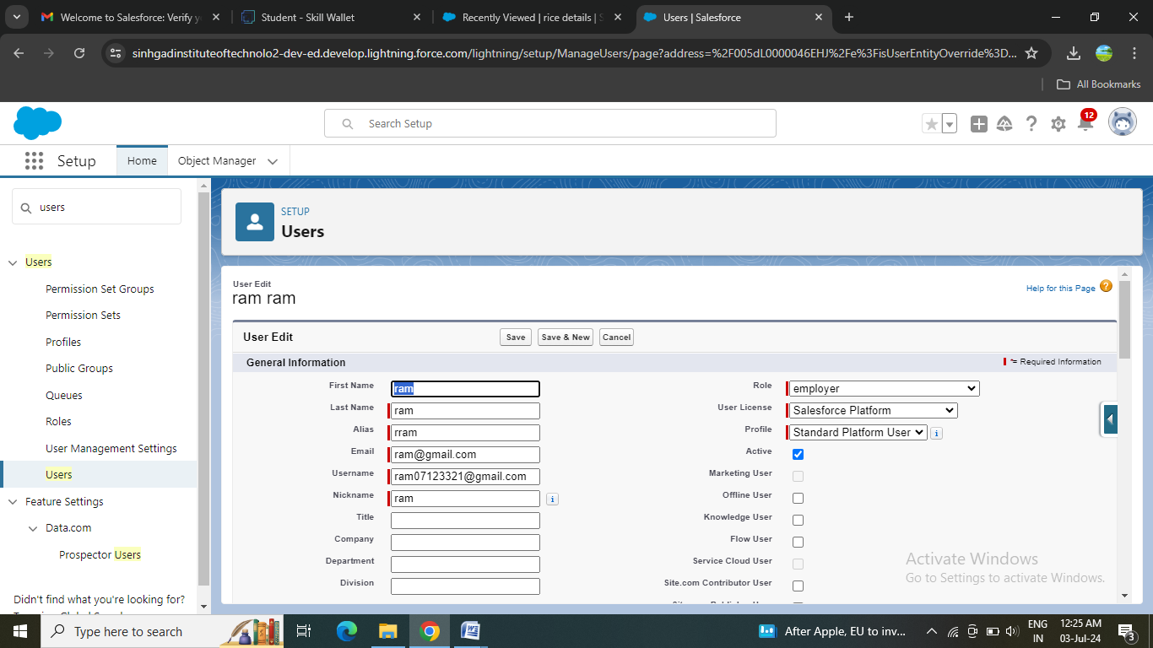

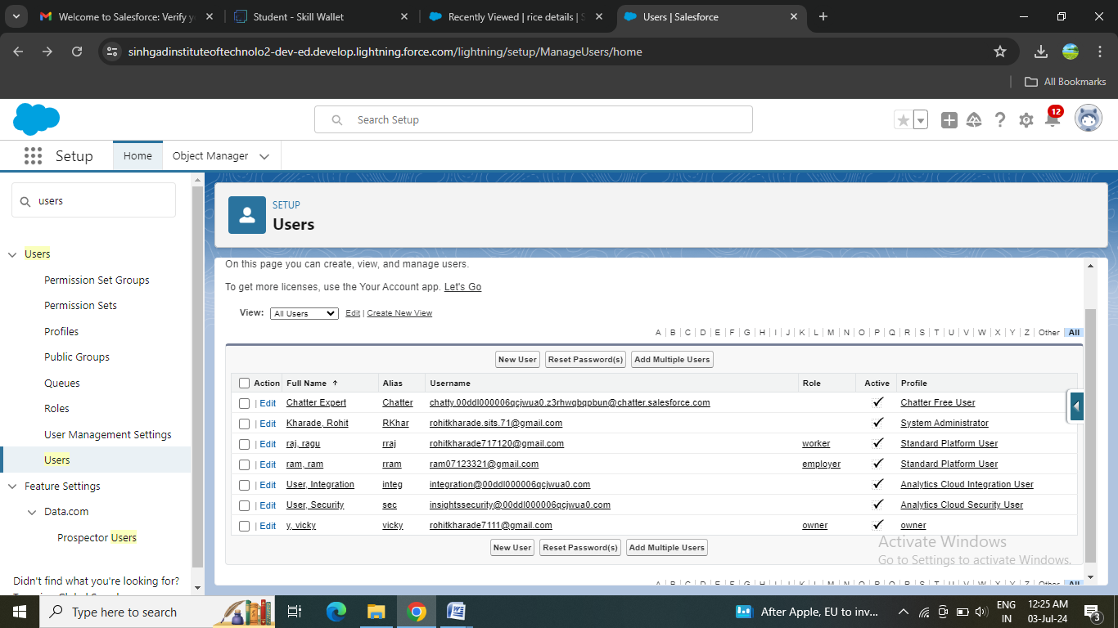

### Permission sets Creation:

### A permission set is a collection of settings and permissions that give users access to various tools and functions. Permission sets extend users’ functional access without changing their profiles and are the recommended way to manage your users’ permissions.

### Creating OWD setting

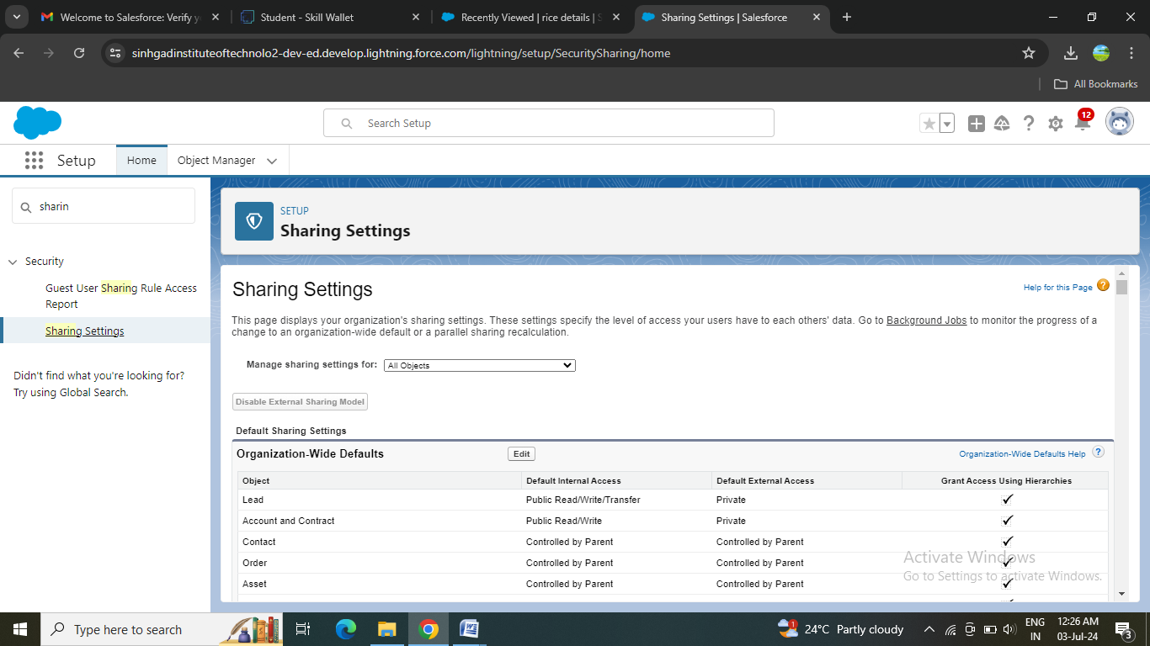

### Reports:

Reports give you access to your Salesforce data. You can examine your Salesforce data in almost infinite combinations, display it in easy-to-understand formats, and share the resulting insights with others.

### Creating Report

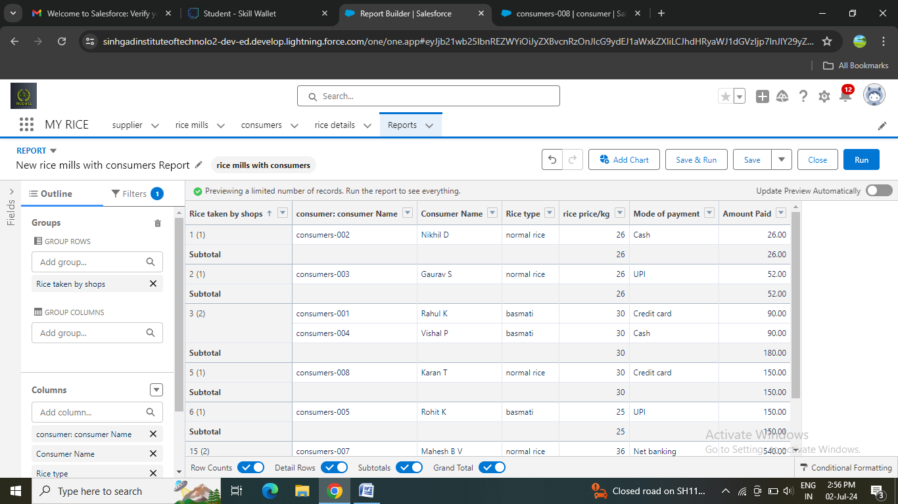

### Sharing report to owner

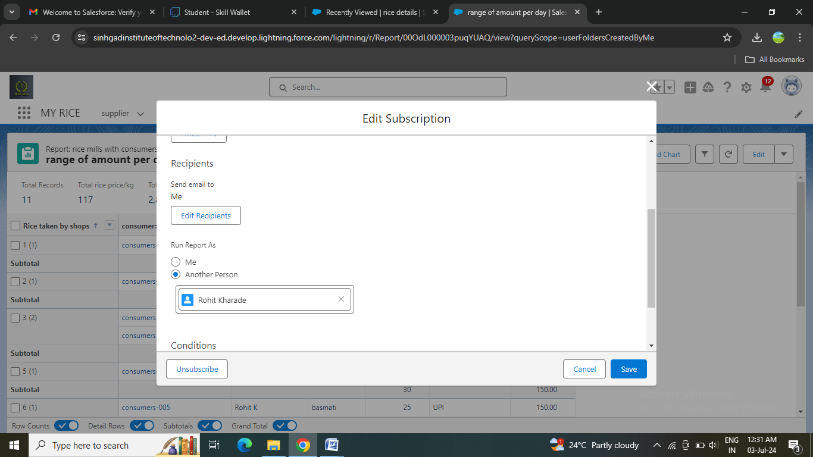

### Create a report folder

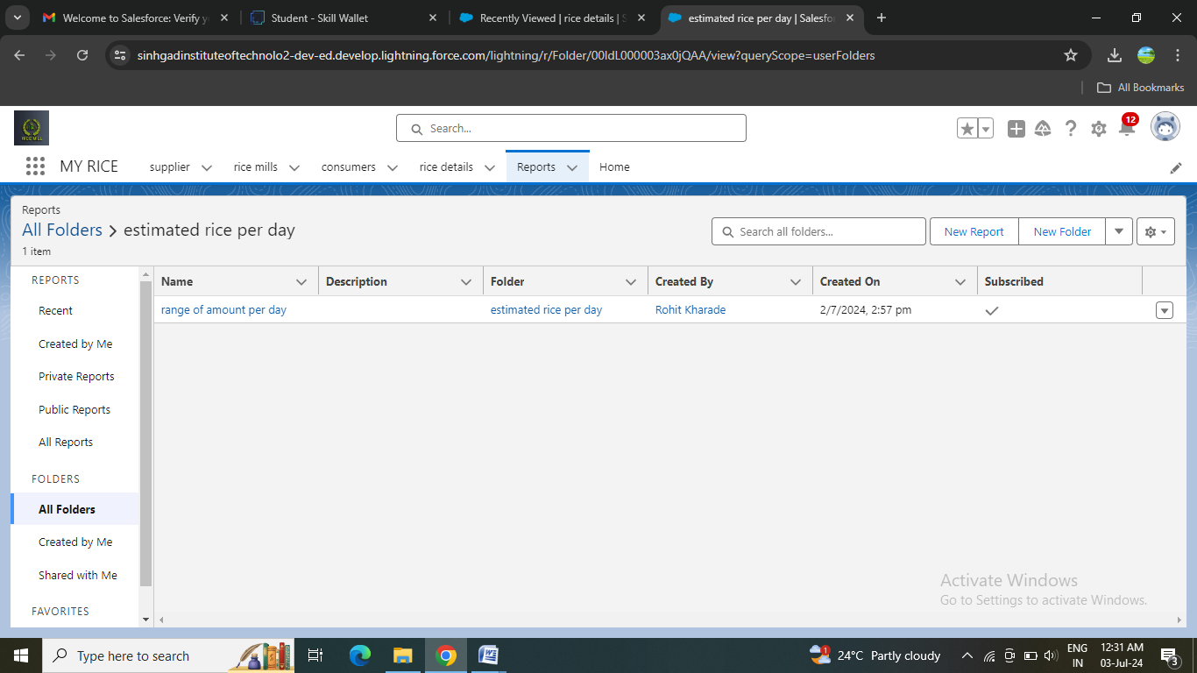

### Dashboards

### Dashboards help you visually understand changing business conditions so you can make decisions based on the real-time data you’ve gathered with reports. Use dashboards to help users identify trends, sort out quantities, and measure the impact of their activities.

### Creating Dashboard Folder

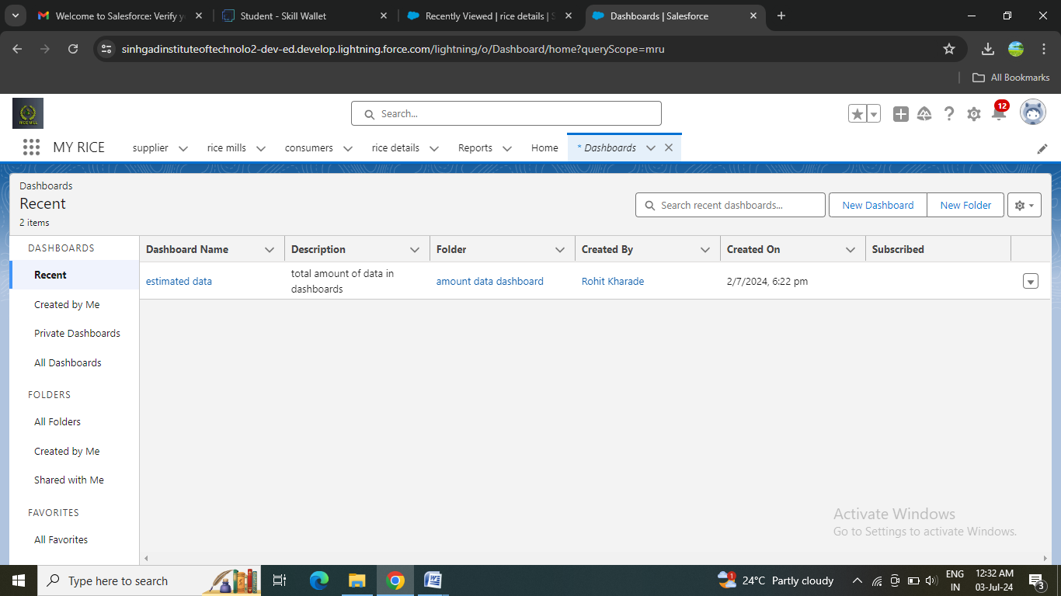

### Creating Dashboard

